

SCHOOL OF INFORMATICS & IT
Diploma in Information Technology

Machine Learning for Developers (CAI2C08)
AY2025/2026 October Semester

Program Codes

Student Name (Matric Number) : Nur Assyakirin Binte Azam (G263434)

Tutorial Group : B01
Jenny LING (TP)
Tutor : Ruchir SRIVASTAVA

Submission Date : 11 February 2026

Declaration of Originality

I am the originator of this work, and I have appropriately acknowledged all other original sources used as my references for this work.

I understand that Plagiarism is the act of taking and using the whole or any part of another person’s work, including work generated by AI, and presenting it as my own.

I understand that Plagiarism is an academic offence
and if I am found to have committed or abetted the offence of plagiarism in relation to this submitted work, disciplinary action will be enforced.

Declaration on the use of Generative AI tools for assignments

Describe how you have used Generative AI tools such as ChatGPT or Dall-E in your assignment.

Share the link to the conversations you had with the AI tool (i.e., the prompts you used and the responses you get from the AI tool).

Please refer to this PDF on “How to share the conversations made with ChatGPT?”

How do you indicate the reference?
The content generated by AI tools are not retrievable except by the user who generated them, so they are considered non-recoverable sources. Although non-recoverable data or quotations in APA Style papers are usually cited as personal communications, with ChatGPT-generated text there is no person communicating. Quoting text from ChatGPT chat is therefore more like sharing the output of an algorithm, with a reference list entry and the corresponding in-text citation.
According to the official APA Style site, ChatGPT references should be cited as:
E.g. OpenAI. (2024). ChatGPT (Feb 13 version) [Large language model].
https://chat.openai.com/chat

Note: The information in parentheses refers to the update or revision date of the model used. Refer to the release notes in the ChatGPT application.

Important Note:

- Do not copy answers produced by the AI tool in totality as it is considered as plagiarism.

- Do not rely on any information produced by the AI tool blindly. You should always verify the answer with other sources. Do not assume that these answers provided by the AI tool are correct.

- To achieve quality outputs from the AI tool, you should provide good prompt that is clear and specific. Be precise and provide context. Avoid asking open-ended questions.

References / Citations / Use of Gen AI tools
Source of dataset | https://archive.ics.uci.edu/dataset/222/bank+marketing  (Bank Marketing)
GitHub link | https://github.com/NurAssyakirin/Bank-Marketing-Streamlit.git
Streamlit link | https://nurassyakirin-bank-marketing-streamlit-app-5dkkop.streamlit.app/

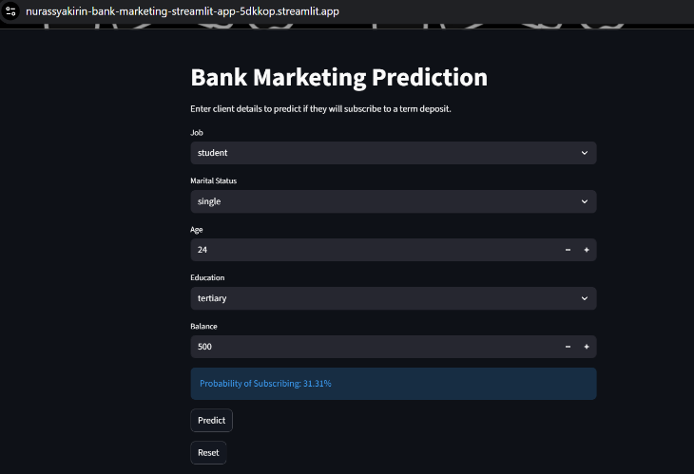
3 screenshots
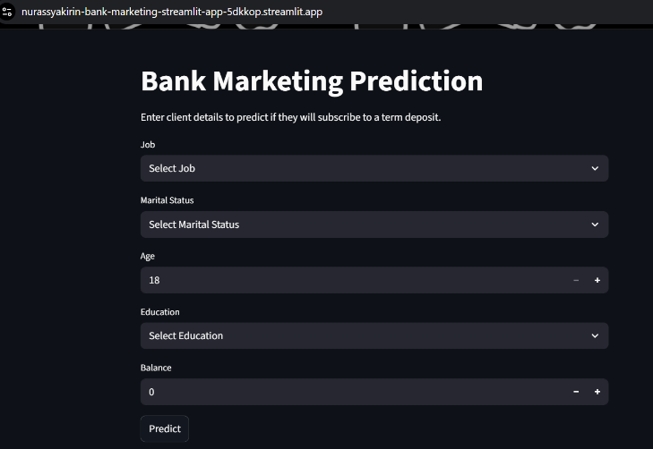
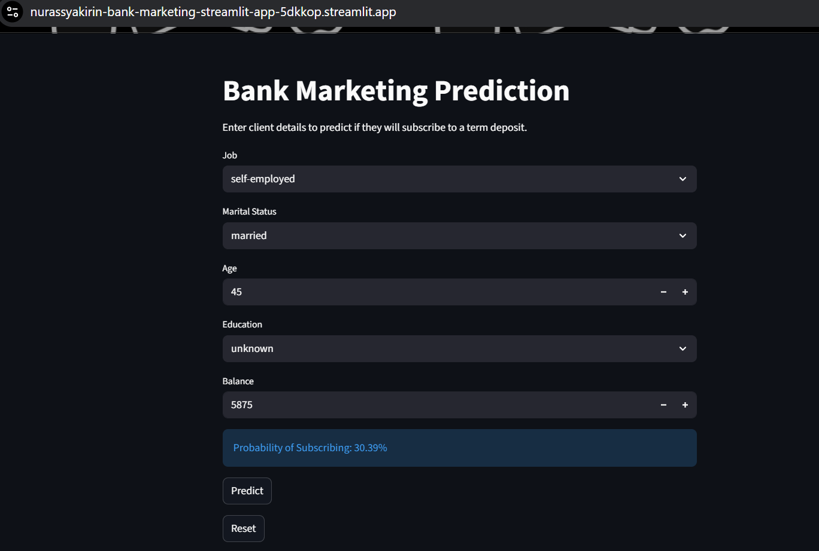
(1) Before any option is selected
It shows a default input state for example:
Job “Select Job”. It shows that user has not input anything in the website.
(2) After an option is selected (should show a prediction)
It shows the Prediction Result after user has input the required fields and clicks the Predict button for example:
Job: “student”, Marital Status: “single”, Age: “24”, Education: “tertiary”, Balance: “500”. It shows the prediction and probability are displayed.
(3) After another option is selected (should show a change in value for the
prediction)
It shows an interaction with the website after changing the inputs for example:
Job: “self-employed”, Marital Status: “married”, Age: “45”, Education: “unknown”, Balance: “5875”. User will click predict button which then the prediction changes shows the app updates dynamically.

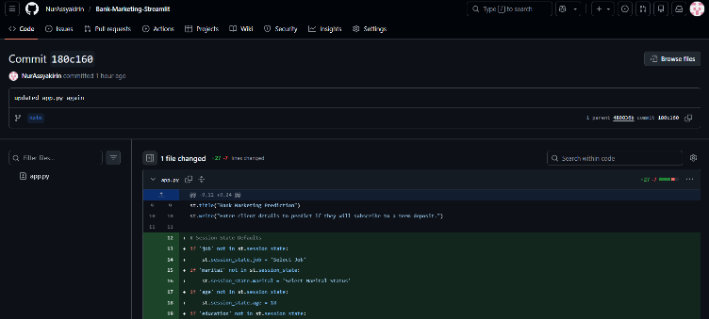
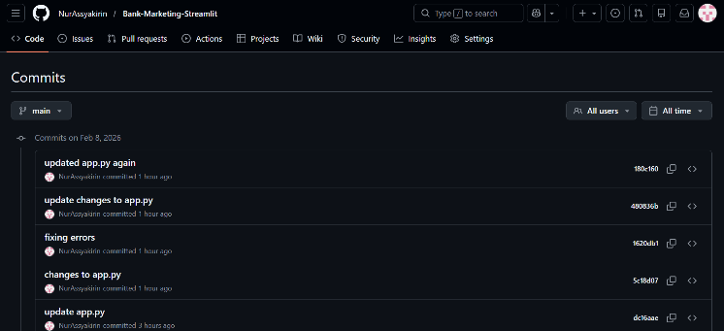
Screenshots of version control or development logs (if applicable)

